Graphics Lies, Misleading Visuals Examples

**Pew Research data visualization shows use of different social media platforms between 2012 and 2018**

1. **Hiding relevant data**

Hiding relevant data or highlighting a particularly beneficial or positive data point can lead learners to focus on a small fraction of the data story—at the expense of accurate understanding of the bigger picture. Any individual parameter or statistic **can** reveal interesting or useful information. But taken out of context, it can also be misleading.

As an example the following Graph it is based on Pew Research Center’s Social Media Use in 2018, which focus on the line of Facebook lead to fact that 68% of American adults use Facebook.

An eLearning or marketing strategy might be built around Facebook, with the architects believing that Facebook exposure is the golden ticket to reaching more members of their audience.

But a deeper look at the data shows that Facebook use has been flat since Pew’s previous study in 2016. It also shows a whopping 25 percent increase in Instagram use during the same period—from 28 percent of American adults to 35 percent. The increase is primarily among younger users. A company seeking to appeal to these learners might want to consider a multiple-platform strategy or focus its efforts on the up-and-coming platforms.

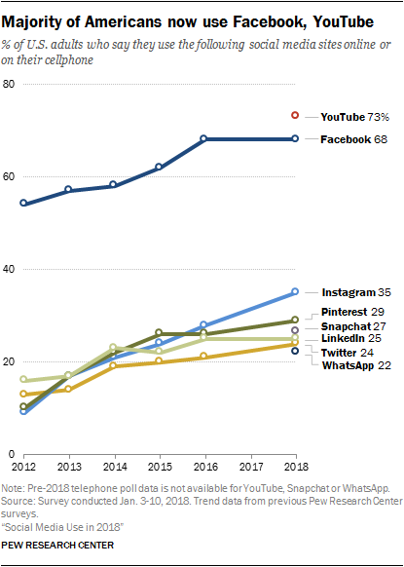

**Source**: Pew Research Center <https://www.pewinternet.org/2018/03/01/social-media-use-in-2018/>

**Intended Audience**: learners or Researchers, because usually research center’s surveys targets researchers.